**MP3 Blast Box**

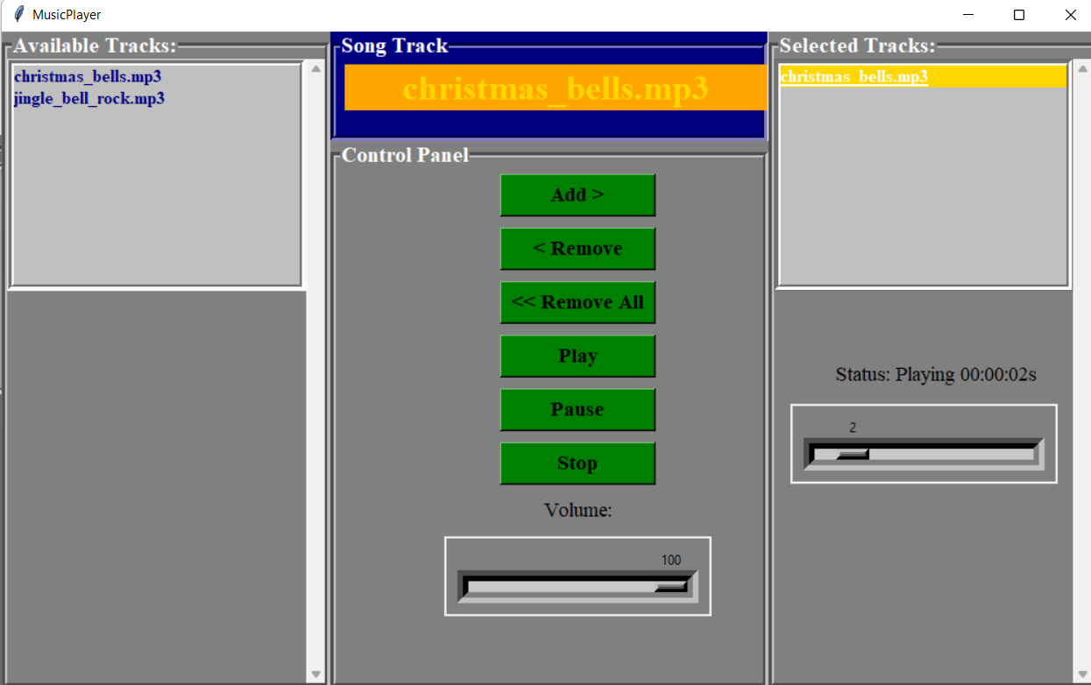

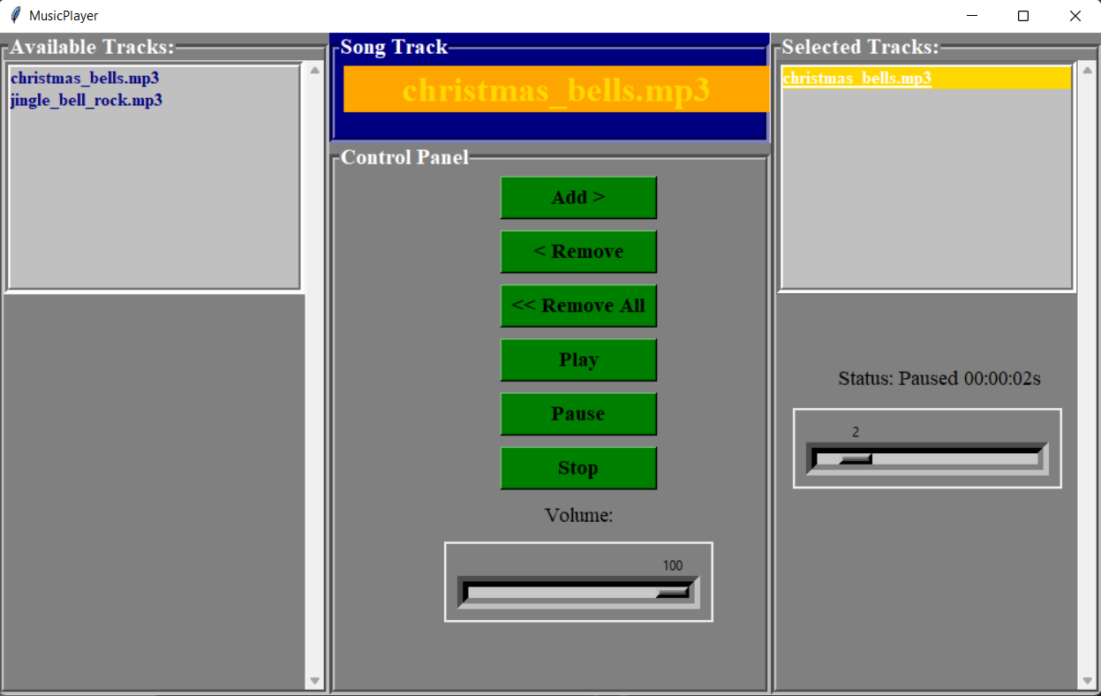

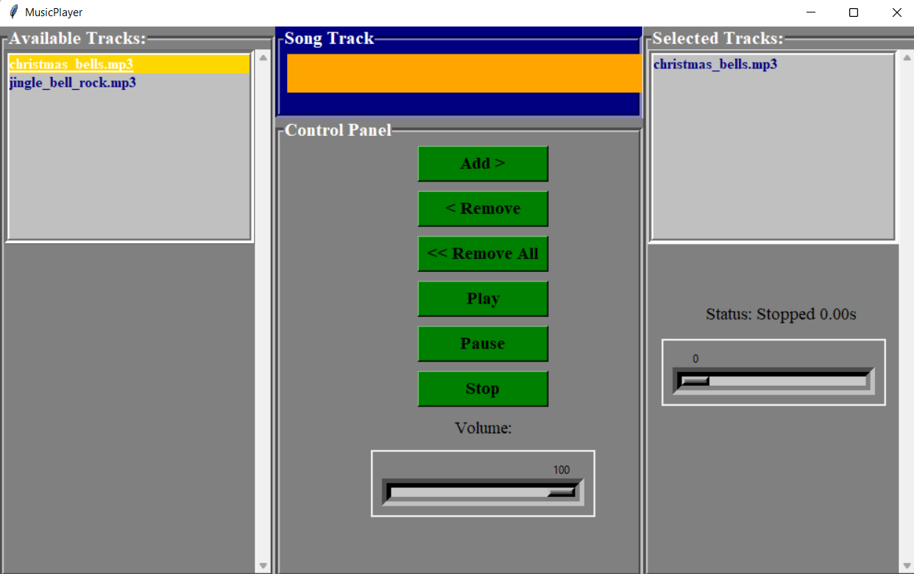

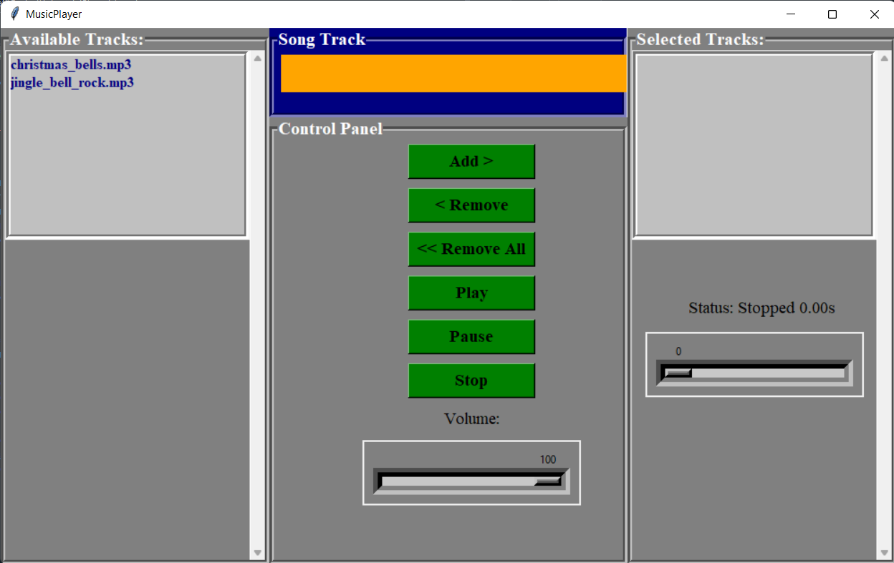

**GUI Implemented using Python 3.10 and Tkinter library**

**LabelFrame for different frames/panels, ButtonFrame, Button, Scale for slider, ListBox for playlist**

**File contains music.py**

**Features Implemented**

* **Add new songs to Selected Playlist from available tracks**
* **Remove a song from Selected Playlist**
* **Remove All from Selected Playlist**
* **Song Track to display name**
* **Volume Bar of song**
* **Seekbar of the song**
* **Status of the song and time bar**

**Location of different segments placed accordingly in a grid as table rows and columns**

**Colour choosing is done matching a modern look**

**All implemented parts are working perfectly**